**Easy Class**

Project Proposal

By

|  |  |
| --- | --- |
| **Pichet Potha** | **542115041** |
| **Sittipong Borripan** | **542115066** |

Department of Software Engineering

College of Arts, Media and Technology

Chiang Mai University

Project Adviser

______________________________

Ms. Yun Rim Park

**Table of contents**

**Revision History**……………………………………………………...........................................................1

**Abstract**….....................................................................................................................................................3

**Chapter I: Introduction and Background**………………………………………………………………..4

**Chapter II: Literature Review**……………………………………...……………………………………..5

2.1 Business Review……………………………………………………………..…………………5

2.2 Alternative Business related…………………………………………………..………………..6

2.3 Technology Review…………………………………………………………..……………......9

2.4 Development Tools Review………………………………………………….……………….14

**Chapter III: Quality Standard**…………………………………………………………...………..…15

3.1 ISO29110 for Very Small Entity (VSE)……………………………………..………………..15

3.1.1 Project Management process………………………………………………..………………15

3.1.2 Software Implementation process…………………………………….….………………….15

**Chapter IV: Project Plan**...........................................................................................................................16

4.1 Motivation……………………………………………………………….……………………16

4.2 Aims and Objectives………………………………………………………….………………16

4.3 Deliverables and Limits……………………………………………………………..………...17

4.3.1 Deliverables…………………………………………………………….…………..17

4.3.1.1 Architecture Overview………………………………………………..…17

4.3.1.2 Documents……………………………………………………...……….18

4.3.2 Limits………………………………………………………………………………18

4.4 Future Work…………………………………………………………………………..……….18

4.5 Schedule and Milestone……………………………………………………………………...18

4.5.1 Features…………………………………………………………………………….18

4.5.2 Software Development process ……….……………………………….…………...20

4.5.3 Milestone……………………..…………………………………………………….21

4.5.4 Schedule …………………………………………………………………………...22

4.5.4.1 Proposal……………………………………………...…………………..22

4.5.4.2 Progress report I………………………………………...……………….23

4.5.4.3 Progress report II………………………………………...………………24

4.5.4.4 Progress report III………………………………………….…………….25

**Chapter V: Reference** …………………………………………………………………………………..26

**Revision History**

|  |  |  |  |  |  |  |  |  |
| --- | --- | --- | --- | --- | --- | --- | --- | --- |
| **Document Name** | **Version** | | **Status** | | **Date** | **Viewable** | **Reviewer** | **Responsible** |
| Easy_Class_Proposal_Version0.1 | Add | * Change the title to “Easy Class” * Technology Review * Motivation * Aims and Objectives * system architecture * Feature | | Draft | 13/03/2014 | PP,SB,YP | PP,SB | PP,SB |
| Easy_Class_Proposal_Version0.2 | Edit  Add | * Technology Review * Motivation * Aims and Objectives * Features * Reference | | Draft | 14/03/2014 | PP,SB,YP | PP,SB | PP,SB |
| Easy_Class_Proposal_Version0.3 | Edit  Add | * Deliverables and limits * Features * Reference * Document in Deliverables and limits * Limits in Deliverables and limits * Schedule & Milestones | | Draft | 15/03/2014 | PP,SB,YP | PP,SB | PP,SB |
| Easy_Class_Proposal_Version0.4 | Edit  Add | * Features * Reference * Business Review * Alternative Business Related | | Draft | 15/03/2014 | PP,SB,YP | PP,SB | PP,SB |
| Easy_Class_Proposal_Version0.5 | Edit  Add | * Business Review * Alternative Business Related * Deliverables * Features * Reference * ISO29110 for Very Small Entity (VSE) in Chapter III | | Draft | 16/03/2014 | PP,SB,YP | PP,SB | PP,SB |
| Easy_Class_Proposal_Version0.6 | Edit  Add | * Chang version form x.x.x to x.x * Technology Review * Reference * Business Review * Development Tool Review * Limits * Future Work | | Draft | 18/03/2014 | PP,SB,YP | PP,SB | PP,SB |
| Easy_Class_Proposal_Version0. | Edit  Add | * Technology Review * Software development process. | | Draft | 18/03/2014 | PP,SB,YP | PP,SB | PP,SB |
| Easy_Class_Proposal_Version0.8 | Edit  Add | * Technology Review * Development Tools * Motivation * Reference * Abstract * Introduction and Background | | Draft | 19/03/2014 | PP,SB,YP | PP,SB | PP,SB |
| Easy_Class_Proposal_Version0.9 | Edit | * Technology Review * Development Tools * Motivation * Aim and Objective * Limits * Future Work * Feature * Software Development Process * Reference | | Draft | 19/03/2014 | PP,SB,YP | PP,SB | PP,SB |
| Easy_Class_Proposal_Version0.10 | Edit | * Technology Review * Development Tools * Aim and Objective * Limits * Future Work * Feature * Milestone * Reference | | Draft | 22/03/2014 | PP,SB,YP | PP,SB | PP,SB |
| Easy_Class_Proposal_Version1.0 | Edit | * Abstract * Introduction and Background * Technology Review * Aim and Objective * Feature * Milestone * Schedule | | Release | 22/03/2014 | PP,SB,YP | PP,SB | PP,SB |

**Abstract**

The Smart Classroom is a new way or a new choice for teaching in school, university, or other academies. It is a teaching environment which uses new technology devices and software in the process of teaching and learning. The Smart Classroom software usually has features to control and manage those technology devices. Teachers can control the devices to make students pay more attention and have fun in class. But there are only a few features that support teaching in class. Teachers may have difficulty creating class activities to make students have fun and get a better understanding of the class content.

“Easy Class” is a Web Application that aims to help teachers create class activities easily. Teachers can create and design activities to make students get more involved in class activities and feel more fun in the class. The system is implemented in HTML5 and CSS3 that provide appropriate, modern user interface ready to give interesting on students and also collaborative with the features. For example is screen boardcast, it allows teachers sharing screen of own device to students. It maybe uses for collaborative search or mind mapping learning. The system also provides teachers with the convenience such as checking students’ attendance and getting their attention with pop up messages, which makes managing a classroom easier and teaching more efficient and effective.

**Chapter I: Introduction and Background**

Education is one of the most important things that any countries emphasize to improve and upgrade themselves. Education has a direct impact to students who will be the key personnel in administrative roles and developing the country in the future. In addition, the educational measurement points are also an indication of the quality of education and the development of the country. That is why many countries try to improve their education policies, course contents, and teaching equipment or learning styles to elevate the quality of education.

One of solutions for solving these problems is using a new technology in the learning process in the classrooms, which is often referred to as “Smart Classroom”. Smart Classroom uses the technologies and devices that many people always use in daily lives such as tablets, smartphones, computers, smart TVs, or projectors. In addition, it may also integrate some new technologies that are not yet widespread because they are not quite mature (i.e. still in development or testing phases) or require expensive software or hardware. Some of good examples are smart table, smart projector, smart board, etc.

Many Smart Classroom software used in school or university always includes the software that helps control and manage the overall smart classroom system. Each software may also include features for teachers to create teaching materials and contents.

There are many applications that are designed to support teaching and learning in schools and universities. They usually support the core feature, which allows teachers to create, update, and delete assignments and study materials for their students. Teachers may also share their screen by displaying it on their students’ devices and monitor the students' screens, etc. Those applications support students also by providing them with access to the assignments and learning materials anytime and anywhere They can also submit their assignments and homework using the system features,

In this project, we propose “Easy Class”, a system that helps change our classrooms ‘smarter’. The system provides a set of features that support teaching and learning activities in class. These features allow teachers to design and create their own class activities. Teachers can adapt each feature appropriately to suit their teaching plan and style. For example, Mind Map is a feature that supports teachers and students creating a mind map collaboratively. Teachers may assign students to make a conclusion with the mind map in group work, pair work, or individual work. In addition, this system is the Web Application. It is comfortable for teachers and students to use this application system. Teachers and students can use all features via a web browser and do not need to install anything on their device to use the system, which makes it easier for users to use the system.

This application system will offer a new experience in class with technology devices and the features that come with the system.

**Chapter II: Literature Review**

**2.1 Business Review**

The Smart Classroom is a new alternative to traditional teaching environment today. Every day, many new technology devices are released in the market. Those devices come to participating in our daily lives more than in the past. Tablet, smartphone, and laptop are the devices that many of us use daily. And now, The Internet network systems are improved so much. People can access the Internet everywhere and every time at fairly high speed. In addition, there are many companies that produce and develop the devices such as projector, smart board, smart table, etc., which can support the services in many business areas. The Smart Classroom is a general name for those classrooms that use such devices and other technologies to improve teaching and learning. Using tablets, laptops, projectors, or personal computers connected to the wired or wireless Internet, the Smart Classroom tries to take advantage of the advancement of technology and make the process of teaching and learning more suitable for the new generation of students.

The Smart Classroom uses technology devices and Internet network in class. Teachers have a lot of choices for instructional media that can be used in class such as photos, video clips, games, animations, etc. These things can help the teachers to create and conduct class activities more easily. They can also help students get a better understanding of the class contents. Students can see what they are reading or learning visually, instead of just relying on their imagination from the content and a few photos in the book. In addition, they can search more information by themselves from the Internet. They can see the model of the things that are difficult to see in the real world such as planets. The Smart Classroom will provide students with a new experience in class. Students will feel more fun and be more curious and collaborative. And they may understand more and participate more in class activities.

Besides, the Smart Classroom can provide more convenience to teachers and students. It can reduce paper usage because teachers and students can save lesson materials or exercises in the form of electronic files and each file type and keep them on the server or in their own device memory. Teachers and students may not need to bring too many books or documents when they come to class. During the class session, teachers do not need to worry that students may not pay attention to the lesson because there is software that helps the teachers to monitor and control the class.

The Smart Classroom does not specify how its components and features are used in class. Each school, university, or other academies can decide how to use the Smart Classroom appropriately with their own courses. The benefit and quality will up to the design of the courses and the ideas of teachers or schools on to use the system.

**2.2 Alternative Business Related**

**2.2.1 Radix SmartClass** [1]

Radix SmartClass is the classroom management software that supports teachers and students doing activities in the classroom with their devices such as PC, tablet, or smartphone. Teachers and students use the Wi-Fi network to connect with each other without a middleware server or hardware. All study abilities students perform can be monitored and controlled from the teachers’ tablet or PC.

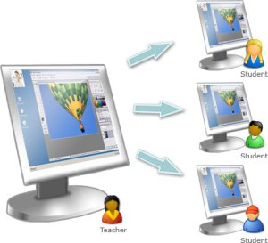

##### **Figure 1: The example of feature in Radix SmartClass:**

##### **Broadcast the teacher’s screen to all or selected student screens**

**Feature:**

* Screen Sharing.
* Screen Monitoring.
* Collaborative whiteboard.
* Screen locking.
* Chat.

**Pros:**

* Does not require extra hardware or servers to be the middleware for connection, which reduces cost and makes it easier to set up and maintain the system.
* Supports multiple languages (e.g. English, Spanish, French, Italian, Thai, Chinese, etc.)
* Supports major platforms such as Android, IOS, and Window.

**Cons:**

* Focuses mostly on classroom management and control and provides few features for supporting teaching and learning activities in the classroom.
* Does not provide storage space for teaching materials and the artifacts of learning activities.

**2.2.2 Classteacher Learning Systems [2]**

Classteacher Learning Systems is one of the very first interactive classroom technologies developed in India (Classteacher is one of the foremost education companies in India). It provides solutions such as Digital Interactive Classroom Program, Classpad, Assessment Program, Digital Math Program, Digital Science Program, Online Program and Digital Language Program. It offers a wide set of technologies and tools to support schools and improve their teaching and learning process.

**Feature:**

* Digital Interactive Classroom.
* Virtual Learning Environment.
* 3D library.
* Classroom Management Software.
* Science Worksheets for Kids.

**Pros:**

* Provides many tools and technologies to support schools and students such as Classroom Management Software, 3D Library, Computer, LED, Interactive Whiteboard, tablet, etc.
* There are always provides frequent update the application and resource to support teaching and learning because they have developer team specific for create, and update.

**Cons:**

* Costs high for service, software, and tools.
* Does not allow teachers to design and create their own class activities.
* Requires devices with high specification.

# 2.2.3 Samsung Smart School [3]

The Samsung Smart Classroom is the software that incorporates the Samsung GALAXY Note 10.1 tablet, e-board, Personal Computer, and a network environment in each classroom. The schools will have their own central server in school to store course contents and user information. They can use these devices to make the Interactive Teaching and Learning Management, which allows b teachers to use a tablet or PC to share their screen with students as well as the e-board. Students can participate in the class using their tablets.

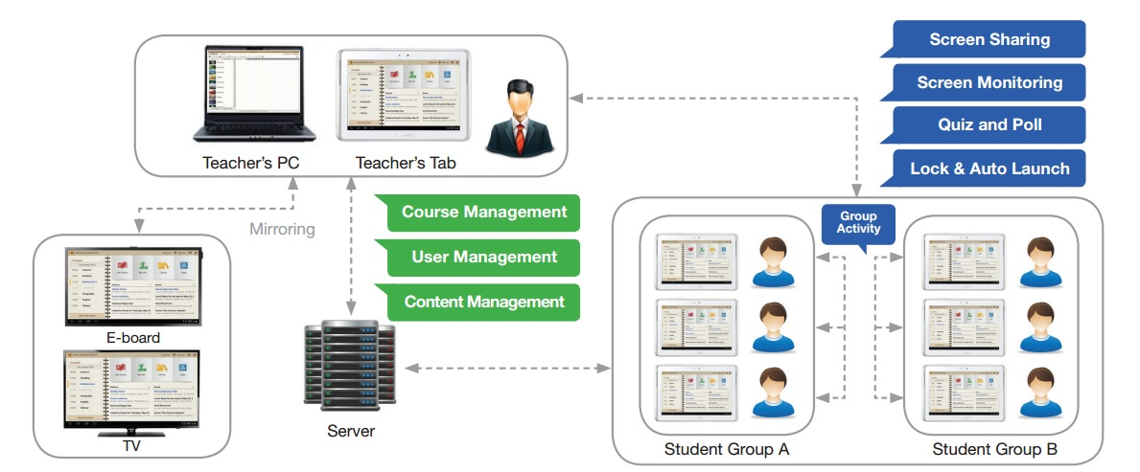

**Figure 2: Samsung Smart School solution structure**

**Feature:**

* Screen Sharing
* Group Activity
* Quiz and Poll
* Whiteboard and S Note
* Learning Management (Course Management, User Management, Content Management, Communication, Notice Board)

**Pros:**

* Software features and device features support each other to make users use them with full efficiency.

**Cons:**

* Supports specific devices only (Samsung GALAXY Note 10.1).
* The other devices should be compatible with the Samsung GALAXY Note 10.1 for connection.

**2.3 Technology Review**

**2.3.1 HTML5 [4]**

**Overview**

HTML is the main markup language for creating webpages and other information that can be displayed in a web browser.So HTML5 is the latest standard of HTML. It was specially designed to deliver rich content without the need for additional plugins. HTML5 is also cross-platform. It is designed to work whether you are using a PC, or a Tablet, a Smartphone, or a Smart TV.

**The interesting features in HTML5 are following list**

* The <canvas> element for 2D drawing
* The <video> and <audio> elements for media playback

**The selection of this technology**

* Supports a systemacross platforms and across browsers
* Can use JavaScript to increase performance

**2.3.2 JavaScript [5]**

**Overview**

JavaScript (JS) is a dynamic computer programming language. It is most commonly used as part of web browsers, whose implementations allow client-side scripts to interact with the user, control the browser, communicate asynchronously, and alter the document content that is displayed Now JS have the ability about real time communication (WebRTC) supporting on latest browser.

**The selection of this technology**

* Supports validating input forms.
* Supports interactivity create on web application.
* Supports look the same in every browser.
* Supports JavaScript code directly into a text editor.

**2.3.3 JSON [6]**

**Overview**

JSON (JavaScript Object Notation) is a lightweight data-interchange format, which is readable for humans. It is easy for machines to generate and parse based on a subset of the JavaScript Programing Language. JSON has a short sentence and a small size of data. So transferring data takes less time. JSON is a good way to transfer synchronous data for web applications and increate performance.

**The selection of this technology**

* Better compact and can be easily loaded in JavaScript.
* Better smaller message size of data.
* Better easy consumed by JavaScript.

**2.3.4 CSS3 [7]**

**Overview**

CSS or Cascading Style Sheets is a style sheet language used for defines layout of HTML such as covers fonts, colors, margins, lines, height etc. CSS3 is a new standard of CSS and also has interesting advantages as follows:

* Flexibility as it separates presentation from content.
* Processing of multiple background images

**The selection of this technology**

* Better work with HTML5
* Better easy to define layouts on HTML

**2.3.5 Node.js & Express.io [8]**

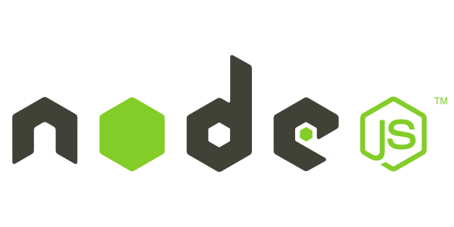

**Overview**

Node.js is the platform that defines a standard around which a system can be developed. Node.js platform is a standard of software platform for server-side JavaScript environment and networking applications based on the *V8 JavaScript engine. It extends JavaScript API to offer usual server-side functionalities. Express.io is the real-time web application framework for node.js. It has many libraries for web application to developers can use.

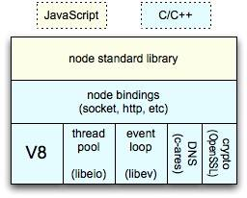

**Figure 3: node architecture**

**The selection of this technology**

* Has high performance, scalable web application and network programs in JavaScript
* Has enables the use of JavaScript on the server-side
* Has a driver for support MySQL
* Has many libraries for developers

* The V8 JavaScript Engine is an open source JavaScript engine developed by Google for the Google Chrome web browser.

**2.3.6 WebRTC [9]**

**Overview**

WebRTC is the API that allows developer to write real-time multimedia applications on the web, without requiring plugins, download or installs. It works across multiple web browsers and across multiple platforms.

The interesting API of WebRTC is a MediaStream. The MediaStream interface of the WebRTC API describes a stream of audio or video data.

**The selection of this technology**

* Can allows devices to communication without plugins
* Can works the across platforms and browsers
* Can supports JavaScript

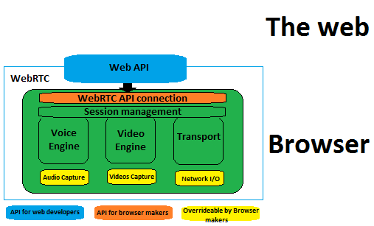

**Figure 4: Architecture of WebRTC**

**2.4.8 MySQL [10]**

**Overview**

MySQL is an open-source relational database management system (RDBMS). It allows user to create a relational database structure on a web-server to store data or automate procedures.

**The selection of this tool**

* Has many users of MySQL and it is open source.
* Has many interacting tools online
* Has good recommending from user in DBMS reviewed*.

*According to the “Top 10 Enterprise Database System to Consider” by Kenneth Hess, the recommended are Oracle, SQL Server, DB2, Sybase, MySQL, PostgreSQL, Teradata, Informix, Ingres, Amazon’s SimpleDB.[14]

According to the “Top 5 Databases for Web Developers” by Curties Dicken, the recommended are MSQL, MicrosoftAcess, Microsoft SQL Server Express, Oracle Express, DB2 Express-C.[15]

According to “Top 10 Most Popular DB Engines(SQL and NoSQL)” by Java, SQL and jOOQ the recommended are Oracle, MySQL, Microsoft SQL Server, PostgreSQL, DB2, MongoDB, MicrosoftAcess, SQLite, Sybase, Teradata.[16]

*Relational database refer to database that has a collection of tables of data items, all of which is formally described and organized according to the relational model. Data in a single table represents a relation, from which the name of the database type comes.



**2.4.9 Google Maps API [11]**

**Overview**

Google Maps is a web mapping service application and technology provided by Google, powering many map-based services. The Google Maps API provides several ways of embedding Google Maps into web pages, and allows either simple use or extensive customization for developers.

**There are several APIs offered:**

* Google Maps JavaScript API
* Google Maps API for Flash
* Google Static Maps API

**The selection of this technology**

* It open source
* It supports JavaScript

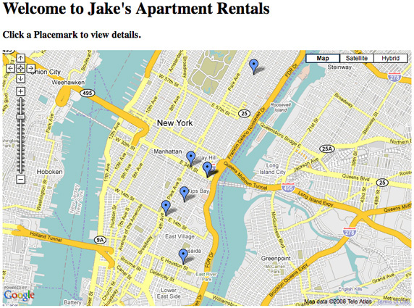

**Figure 5: Example of Google Maps**

* 1. **Development Tool Review**

**2.4.1 Aptana [12]**

**Overview**

Aptana is the open source development tool for the open web, which supports developing and testing the entire web application using a single environment. It provides support for the latest browser technology specs such as HTML5, CSS3, JavaScript, Ruby, Rails, PHP and Python.

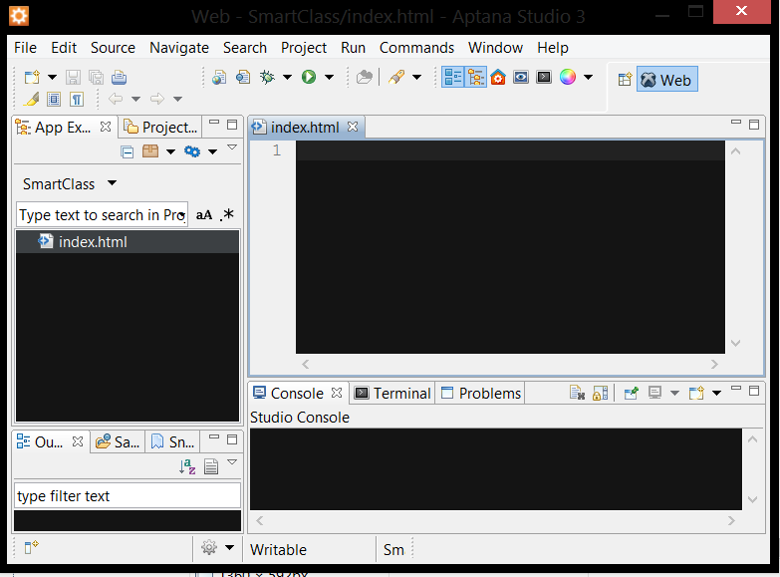

**Figure 6: Interface of Aptana**

**The selection of this tool**

* It supports HTML5, JavaScript and CSS3 writing.
* It open source software.
* It supports testing web applications.

**Chapter III: Quality Standard**

**3.1 ISO29110 for Very Small Entity (VSE)**

ISO29110 is a guide applies to a Very Small Entity (VSE), enterprise, organization, department or project up to 25 people, dedicated to software development. The Guide provides Project Management and Software Implementation processes which integrate practices based on the selection of ISO/IEC 12207- Systems and Software Engineering —Software Life Cycle Processes and ISO/IEC 15289 Software Engineering – Software Life Cycle Process – guidelines for the content of software life cycle process information products (documentation) standards elements.

**3.1.1 Project Management process**

The purpose of the Project Management process is to establish and carry out in a systematic way the tasks of the software implementation project, which allows complying with the project’s objectives in the expected quality, time and cost.

**Selected process**

1. Project Planning Process
2. Project Plan Execution Process
3. Project Assessment and Control Process
4. Project Closer Process

**3.1.2 Software Implementation process**

The purpose of the Software Implementation process is the systematic performance of the analysis, design, construction, integration and tests activities for new or modified software products according to the specified requirements.

**Selected process**

1. Software Implementation Initiation Process
2. Software Requirements Analysis Process
3. Software Architectural Design Process
4. Software Construction Process
5. Software Integration and Test Process
6. Software Delivery Process

**CHAPTER IV: PROJECT PLAN**

**4.1 Motivation**

The traditional classroom setup may be no longer the best environment for teaching and learning in schools because new technologies have grown quickly, which can support both teachers and students in various ways. So the challenge and motivation of this project come from how to use new technologies in order to improve and support teaching and learning in schools. We want to change our traditional classrooms to be “smarter” by introducing some new technologies into teaching and learning activities. We have to focus on impossible to use in every subjects of social studies. And we propose to develop a web application that lets teachers and students make use of tablets in classrooms.  Nowadays, tablets are used for many purposes such as entertainment, news, communication, and so on. More and more people are now looking into their potential value in education.

**4.2 Aims and Objectives**

This is aim and objectives of project.

* **Develop the software system that can foster student participation in class activities and promote the interaction between teachers and students.**
  + The project needs to develop the collaboration board that can support collaboration activity in class such as collaborative search student can search to internet together and interaction via their own tablet with teacher.
* The project needs to develop the group chat that can support communication in class such as while teacher needs to make more attention of students he/she can sending pop-up to that student.
* The project needs to develop the mind map for students can free to put their own ideas into the mind map and teacher can gather it to compare on the monitor screen.
* **Develop the software system that can make teaching and learning more fun and interesting.**
  + More convenience to Teacher for interactive to Students such as features, screen broadcast, make a popup message, pop quiz etc.
  + More efficient of collaboration in classes such as features, collaborative search (allows Students to search on internet together).
  + More interesting with the visual media to students such as feature, graphical representation (shown the past lesson learned graphical), and data static graph.
* **Develop the software system that reduces the amount of manual work and paper used in classrooms.**
* Can using the Class Board and tablets to share study materials and take notes.
  + Can capture the Class Board in pdf format and store it on the server.
  + Can capture the student’s screen in pdf format and store it in the tablet.
  + Can sharing the teaching/learning artifacts via social network (e.g. Facebook).

**4.3 Deliverables and Limits**

**4.3.1 Deliverables**

**4.3.1.1 Architecture Overview**

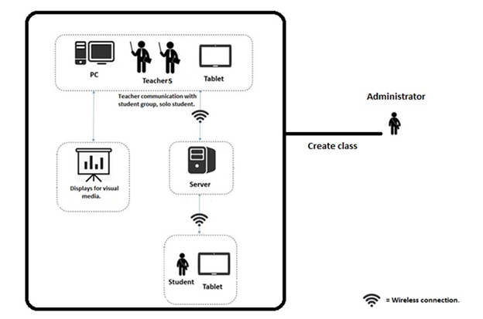

**Figure 7: The architecture of the Easy Class.**

**The architecture consists of two parts:**

* Server (Administrator)
* Class (Teacher, Students)
* Personal Computer(PC)
* Tablet
* Projector

Administrator is a person who manages and controls the server. He can create and manage a classroom (e.g. add, edit, and delete a teacher and students). Teacher can use his PC or tablet to use the system. He can show his screen on the projector and share his screen with student tablets. He can use his tablet to control the class. Student can use the service using his tablet, which allows him to see the class content participate in activities in class. Every activity in class requires Wireless connection to connect with the server.

**4.3.1.2 Document**

* Proposal
* Project plan
* Software requirement specification
* Software design document
* Testing document
* Traceability record
* Software quality assurance document
* Video clips for demo program
* Poster A1 for presentation

**4.3.2 Limits**

* Requires the Internet connection for using this system.
* Supports English language only.
* Requires the browser that supporting HTML5 to run this system (e.g. Chrome, Firefox).
* Requires the registration to get an account before starting to use the system.

**4.4 Future work**

This project is about supporting teaching and learning with the concepts of the Smart Classroom. The Smart Classroom works with many technology devices. So, this project can be improved by adding more features that can be supported by new technologies, for example, Smart Wall, Smart Table, etc.

The license can be implemented for business. This system can use in any school, university, or other academies. Teachers or personnel can adapt this system to serve their courses. This can provide more benefits to a larger group of people and contribute to enhancing the quality of education in educational institutions and organizations.

This system can be improved to support remote education (i.e. e-learning). It will make the students who cannot attend the class be able to learn and do class activities with his friends that are in class.

**4.5 Schedule and Milestone**

**4.5.1 Features**

Easy Class supports the features as follows:

**Feature 1. User management**

* User registration: Administrator, Teacher and Student can register to the system.
* User authentication: Administrator, Teacher and Student can login to system and log out with his/her account.

**Feature 2. Classroom Management**

* Class registration: Administrator can register a class to the system by adding Teacher and Students.
* Classbook management: Teacher can view the list of Students in the class and check their attendance.

**Feature 3. White board for Teacher**

* White board: Teacher can write things down as he does in a regular white board.
* Screen Boardcast : Teacher can boardcast his own screen to Students tablets.
* Subscreen partitioning: Teacher can split his screen into two partitions to display information on one side while using the other side as a white board for writing.

**Feature 4. Monitor Students.**

* Screen monitor: Teacher can see the screen of students

**Feature 5. Collaboration Board**

**A board which gathers input from individual students and displays it, which can be used for survey, drawing and information gathering.**

* Activity creation and management: Teacher can create a collaboration board for survey, drawing and gather information, also can edit or close a board.
* Activity participation: Students can drawing or filling information to collaboration board.
* Student attention: Teacher can automatically check attention of a student by activity participation.
* Gather learning artifact: Student can send activities/teaching, studies material (PDF, Image, pined map and text) to the teachers.

**Feature 6. Grouping communication**

* Group chat: Teacher can chat with all Students in real time.
* Pop-up message: Teacher can create and send an alert or warning message to Students.
* Pop-up quiz: Teacher can create and send a quiz interface to Students.

**Feature 7. Mind map**

* Mind map creation and management: Teacher can create& provide mind map board for student to put ideas (image, text, pin map etc.).
* Collaborative mind mapping: Students can create mind maps of the collaboration or individually for input own ideas (text or image).

**Feature 8. Geographic Map**

* Map Interface: Teacher can open and provide the map interface to students for allows them pin the map.
* Collaboration using map: Students can using the map for searching information and pin the map.

**Feature 9. Uploading/downloading study materials**

* Teacher’s slide: teacher can upload/download any learning artifacts to the server.
* Teacher’s note: teacher can upload/download note on white board to the server.
* Collaboration outputs: Teacher/students can upload/download collaboration output (image, pdf, etc.) to the server.

**Feature 10. Share learning artifact**

* Sending via e-mail: User can send the activities/teaching, studies material (PDF, Image and text) via e-mail.
* Sharing via Facebook: User can share activities/teaching, studies material (PDF file, Image and text) via Facebook.

**4.5.2 Software Development process**

**Iterative Software Development Process [13]**

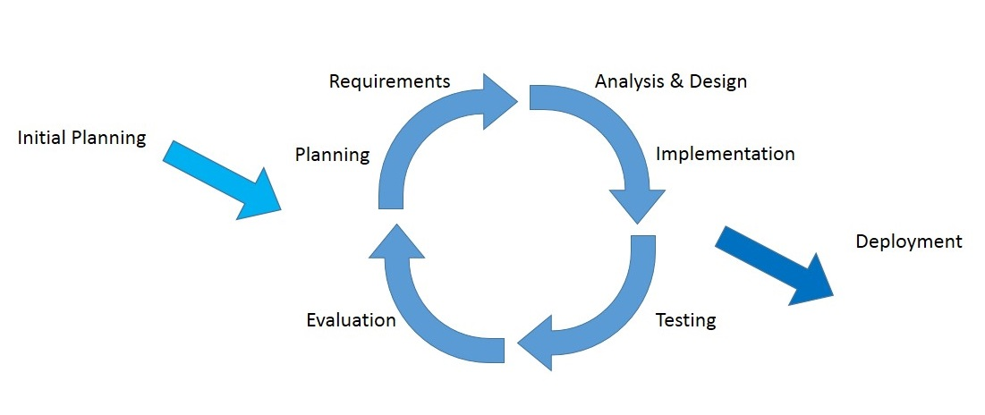

**Figure 8: The diagram of the iterative software development process**

The idea of the iterative software development model is to divide the development process into phases. As shown in Figure 8, the iterative process begins by implementing and specifying a portion of the software instead of specifying the full requirements. It is then reviewed along the way to find and add more requirements as needed. The model is broken down into increments containing a number of smaller life cycle stages with each part including a new function to the product. And each phase must be completed before the start of the next phase and the iterations continues until the entire product is built. Some of the advantages of the iterative development model include: more flexible to accommodate feedback from customers in each cycle, easy to implement sub-systems (or components) that satisfy user requirements, easy to fix errors that occur in the implementation process.

**4.5.3 Milestone**

|  |  |  |  |
| --- | --- | --- | --- |
| **Milestone** | **Task** | **Milestone Criteria** | **Planned date** |
| 1 | Proposal | Topic defined | February |
| 2 | Proposal | - Proposal reviewed  - Proposal submitted  - Proposal presentation | March |
| 3 | Progress Report I | - Software requirement specification  - Feature# 1, 2, 3, 4, 6  - Feature designed  - Test planned  - Feature implemented  - Feature tested  - Review Feature  - Progress report submitted  - Progress report presentation | Mid May |
| 4 | Progress Report II | - Software requirement specification  - Feature# 5, 7, 8  - Feature designed  - Test planned  - Feature implemented  - Feature tested  - Review Feature  - Progress report submitted  - Progress report presentation | Mid July |
| 5 | ShowPro | Overall of the system should be higher than 65%. | Beginning of September |
| 6 | Progress Report III | - Software requirement specification  - Feature# 9, 10  - Feature implemented  - Feature designed  - Test planned  - Feature tested  - Review Feature  - Integrate and review all documents.  - Tests all features.  - Reviews documents are completed.  - Progress report submitted  - Progress report presentation | End of September |

**4.5.4 Schedule**

**4.5.4.1 Proposal**

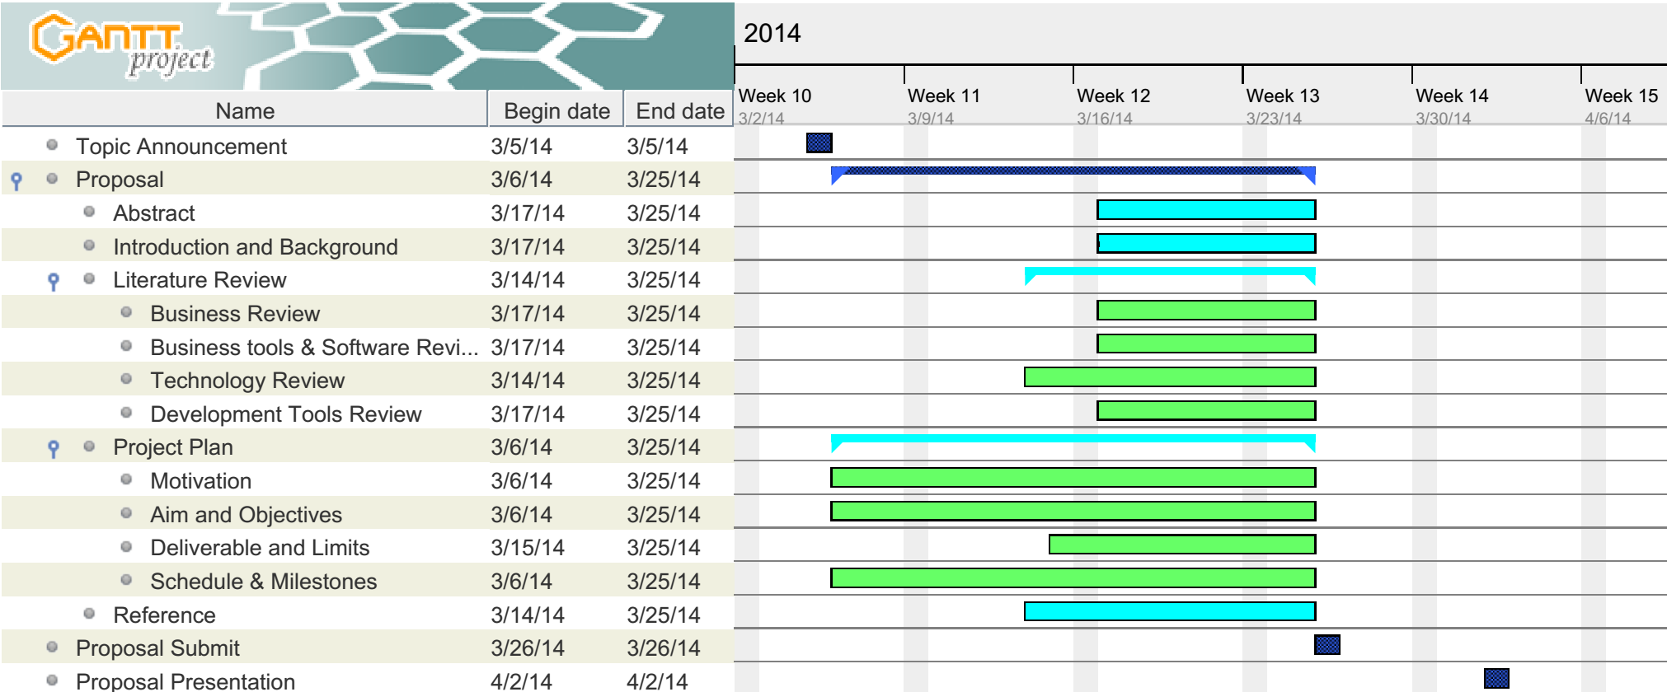

**4.5.4.2 Progress Report I**

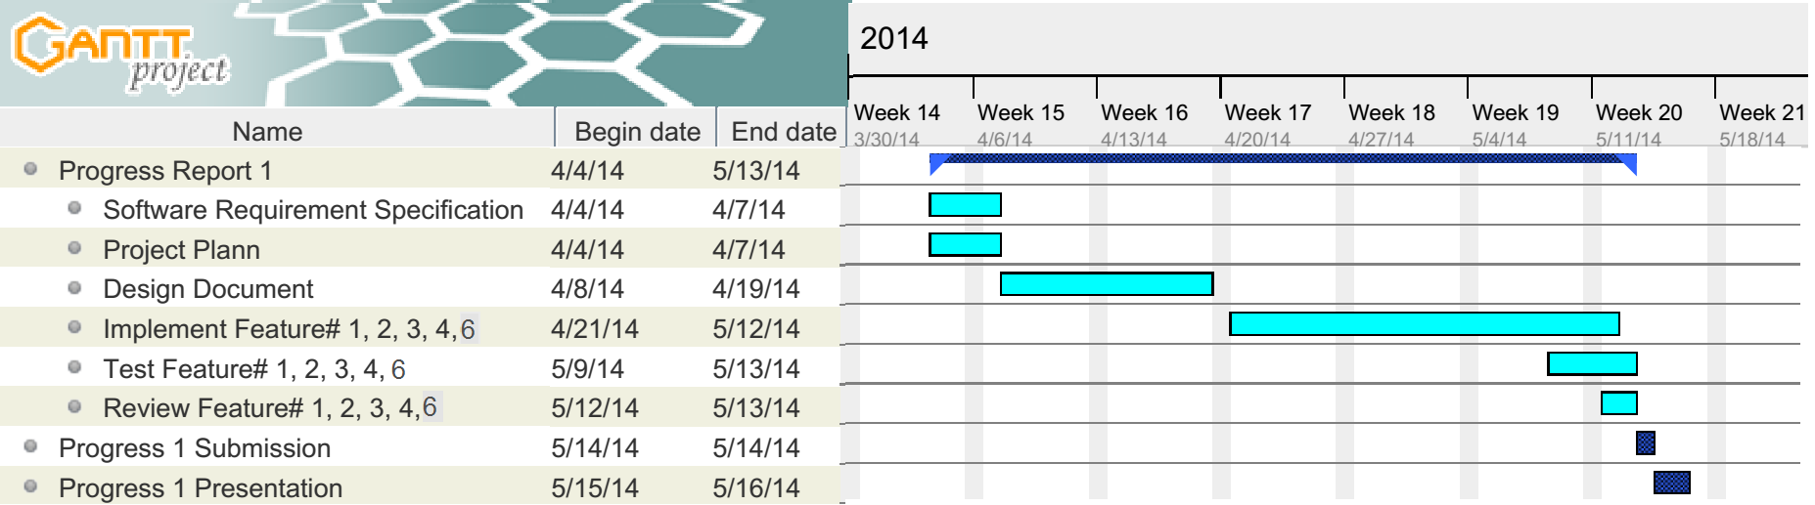

**4.5.4.3 Progress Report II**

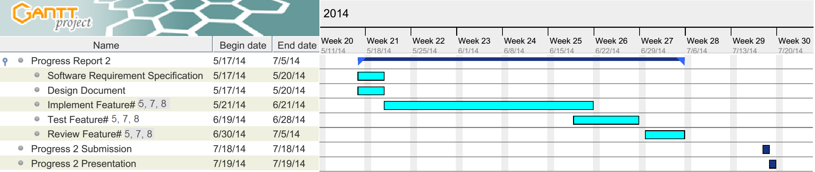

**4.5.4.4 Progress Report III**

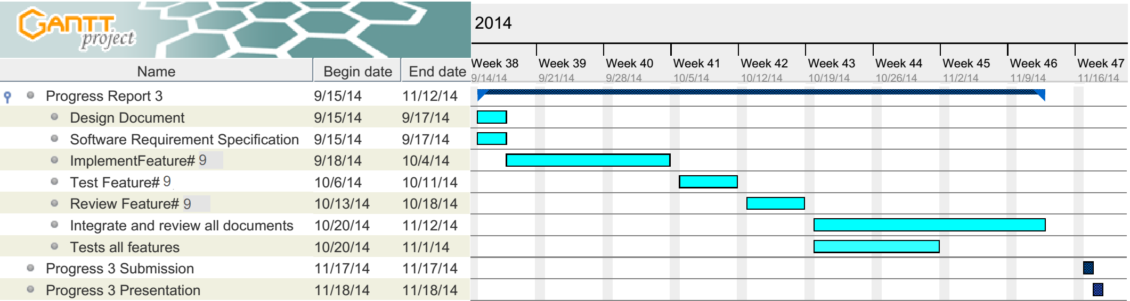

**Chapter V | References**

[1] Tablet Classroom Management Software: Radix Technologies Ltd.

*Available from*: <http://www.radix-int.com/Classroom-Management/Tablet-Classroom-Management-Software.html> [Accessed 16th March 2014]

[2] Classteacher Learning: Systems Classteacher

*Available from:* <http://www.classteacher.com> [Accessed 16th March 2014]

[3] Samsung Smart School: Samsung

*Available from:* <http://www.samsung.com/global/business/business-images/resource/case-study/2013/02/Samsung_Smart_School_Brochure-0.pdf> [Accessed 19th March 2014]

[4] HTML5: Wikipedia

Available from: <http://en.wikipedia.org/wiki/HTML5> [Accessed 19th March 2014]

[5] JavaScript: Wikipedia

*Available from:* <http://en.wikipedia.org/wiki/JavaScript> [Accessed 19th March 2014]

[6]JSON: Wikipedia

*Available from:* <http://en.wikipedia.org/wiki/JSON> [Accessed 18th March 2014]

[7]Cascading Style Sheets: Wikipedia

*Available from:* <http://en.wikipedia.org/wiki/Cascading_Style_Sheets> [Accessed 18th March 2014]

[8] Node.js: Joyent, Inc

*Availble from:* <http://nodejs.org> [Accessed 18th March 2014]

[9] WebRTC API: Webplatform*Available from*: <http://docs.webplatform.org/wiki/apis/webrtc> [Accessed 19th March 2014]

[10] MySQL:

*Available from:* <http://en.wikipedia.org/wiki/MySQL> [Accessed 18th March 2014]

[11] Google Developers:

*Available from:* [https://developers.google.com/*maps*](https://developers.google.com/maps) [Accessed 18th March 2014]

[12] Aptana: Wikipedia

*Available from*: <http://en.wikipedia.org/wiki/Aptana> [Accessed 25th March 2014]

[13] Iterative and incremental development: Wikipedia

*Available from*: <http://en.wikipedia.org/wiki/Iterative_and_incremental_development> [Accessed 25th March 2014] [Accessed 25th March 2014]

[14] Kenneth Hess. Top 10 Enterprise Database Systems to Consider.

*Available from:* <http://www.serverwatch.com/article.php/3883441/Top-10-Enterprise-Database-Systems-to-Consider.htm> [Accessed 25th March 2014]

[15] Curties Dicken. Top 5 Databases for Web Developers.

*Available from:* <http://www.htmlgoodies.com/primers/database/top-5-databases-for-web-developers.html> [Accessed 25th March 2014]

[16] Java, SQL and jOOQ. Top 10 Most Popular DB Engines(SQL and NoSQL)**.**

*Available from:* <http://blog.jooq.org/2013/10/03/the-10-most-popular-db-engines-sql-and-nosql/> [Accessed 25th March 2014]